**Flowchart for Expression Evaluation**

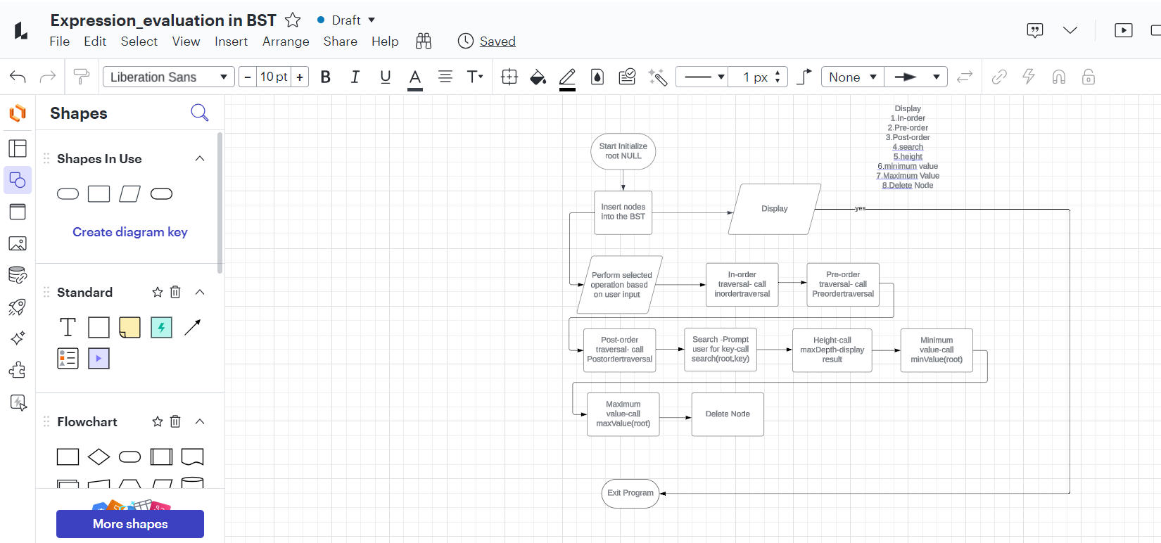

**Flowchart of File System Simulator**

